# Algorithm for file updates in Python

## Project description

["So, I have a list of IPs for all employees, and another list has specific IPs that don't have authorized access. I should develop an algorithm that checks IPs. If there are elements from the second list in the first list, I should use a method to remove these IPs from the second list. So, I will create a loop to iterate over the first list, and a statement checks if there is an element from the second list; it removes it. Then, update the allowed list to containing only authorized employees, and it's removed from any unauthorized IPs in the second list.]

## Open the file that contains the allow list

[To open the file ‘allowed list that contain our authorized employees, we use a with statement >> with open(‘name of the file, ‘r’ ) as file : >> r refer to read mode ]

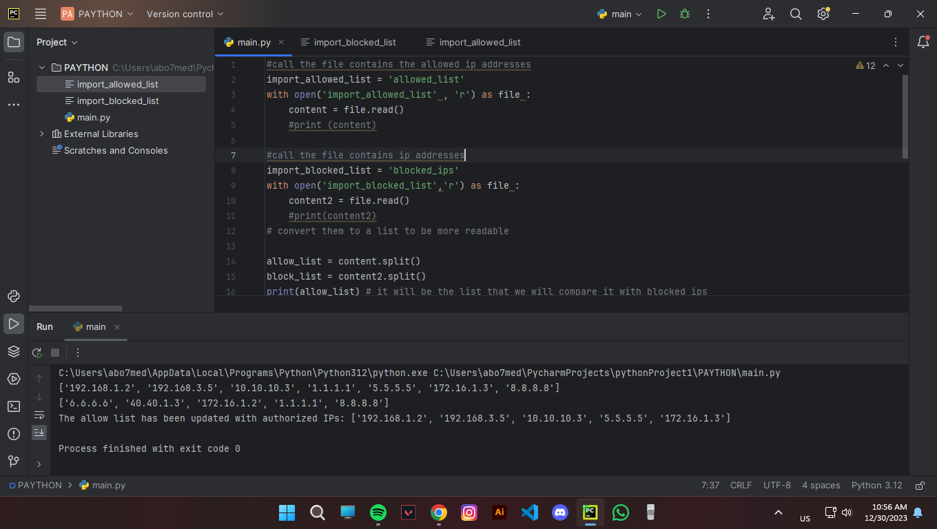

## Read the file contents

[Create a variable store the content of the allowed list and use the function >> file.read() then we can display the content when we print the variable .]

## Convert the string into a list

[Use built in function ‘.split’ to convert the string into a list so it be more readable and usable.]



## Iterate through the remove list

[We use a for loop to iterate the list of the list of removed ips, and if statement compare with allowed list and use ‘ip’ as a variable to the loop >> if ip not in block list:

authorized_list.append(ip)]

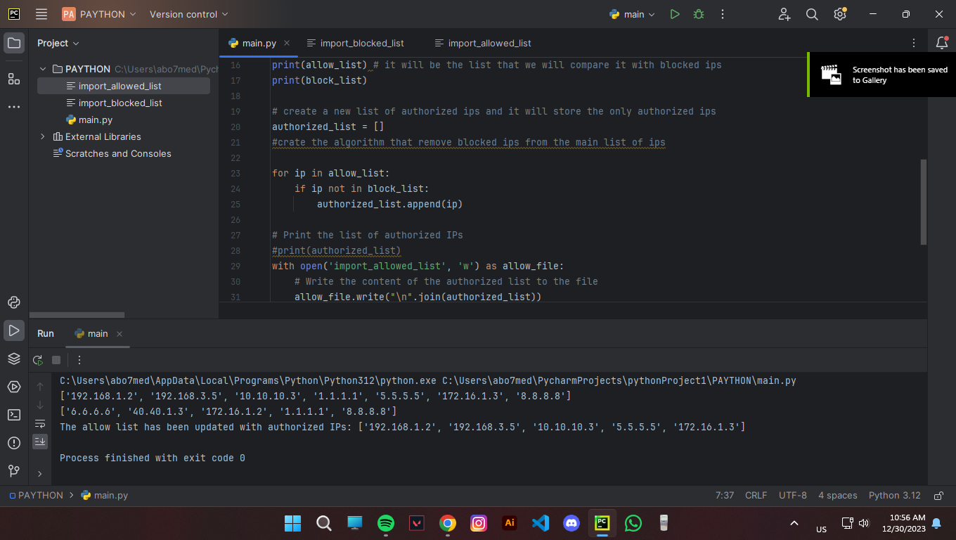

## Remove IP addresses that are on the remove list

[ Assign the names of the files containing the allow and remove lists

, Use 'with' statements to open the files and read their contents, # Remove IP addresses that are on the remove list >> authorized_list = [ip for ip in allow_list if ip not in remove_list] ]

## Update the file with the revised list of IP addresses

[Write the content of the authorized list to the file >> with open(allow_file_path, 'w') as allow_file:

allow_file.write("\n".join(authorized_list))]

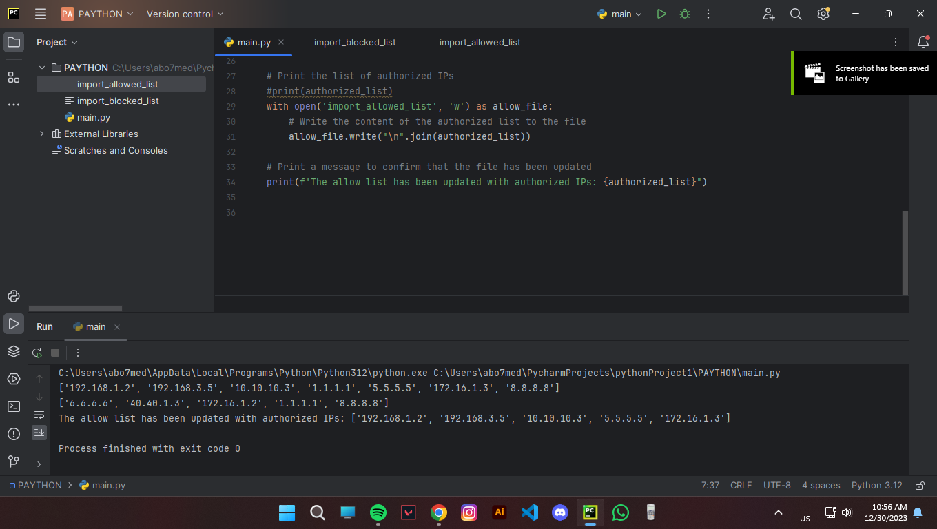

## Summary

[This code essentially performs IP authorization management by removing unauthorized IPs from the allow list and updating the allow list file accordingly.

1. Reading Files:

- The code reads the contents of two files, "allow_list.txt" (containing authorized IPs) and "remove_list.txt" (containing IPs to be removed), into lists.

2. Removing Unauthorized IPs:

- It then creates a new list (`authorized_list`) by filtering out IP addresses from the allow list that are present in the remove list.

3. Updating Allow List File:

- The code updates the content of the "allow_list.txt" file with the revised list of authorized IPs.

4. Printing Results:

- The final list of authorized IPs is printed to the console.

- A message is displayed, confirming that the allow list file has been updated with the authorized IPs.

Project finished (: ]

And this a final result

